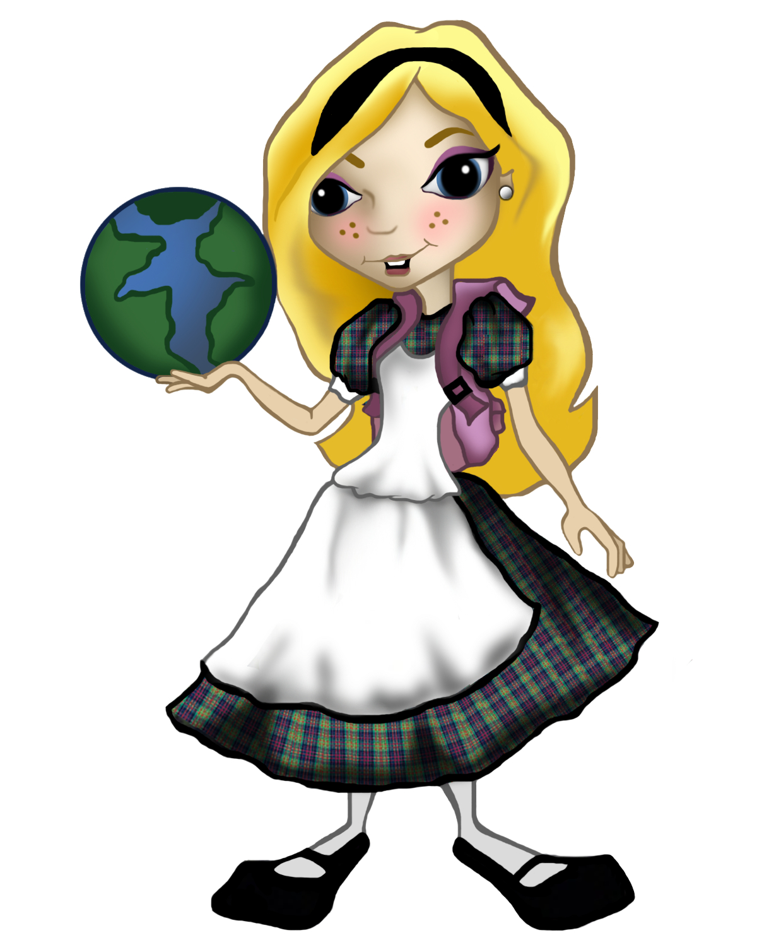
第十三屆全澳資訊科技大賽-ALICE三維編程比賽
The 13th Macao-wide IT Competition-ALICE 3D Programming Contest
說明文檔Documentation
組別（中學組／公開組）：
Category(Secondary/Open):
程式作品標題：
Title of Program:
参賽隊伍成員:
Team members:
學校／公司：
School/Company:
作品類型（故事／遊戲）
Type of Program (Game/Story):
（中學組）(Secondary school category)
執行時間（秒）：
Playtime (in seconds):
（中學組）(Secondary school category)
指導老師（如適用）：
Mentor (if applicable):
序言／背景
Introduction/Background
故事或遊戲的表達(例如主題匹配度、故事完整性、作品整體意念等)
Story telling (Such as match of the theme, story completeness, overall idea of the work, etc.)
技術複雜性（例如編程、影片呈現和3D效果等）
Technical complexity (Such as programming, video presentation and 3D effects, etc.)
創意（例如表達、技術、多媒體等）
Creativity (Such as expression, techniques, multimedia, etc.)
團隊合作
Teamwork
外置物件列表  List of Imported Objects | 圖片  Images
聲音
Sounds
三維模組
3D Models
參考／來源
References/Sources
其他註釋
Other Comments

